SMART LENDER
AI - Powered Loan Approval Prediction Using Machine Learning and Flask

1. INTRODUCTION
Smart Lender is an AI-powered loan approval prediction system developed to assist financial institutions in evaluating loan applications efficiently and accurately. The application uses Machine Learning with a Random Forest classifier to analyze applicant information and predict whether a loan should be approved. The solution is implemented using Python, Flask, and Scikit-learn, providing a simple web interface that helps reduce manual effort, improve consistency, and support faster decision-making.

TEAM MEMBERS
Name | Role
Vishal Kumar | Team Lead
Gowthami Akula | Member
Anisetti Sai Durga | Member
Bikkayolu S Sai Veera Bhadra Ayyan | Member
Bogavalli Akash | Member

2. SCENARIO-BASED CASE STUDY
A bank loan officer receives a customer's application through the Smart Lender web portal. The officer enters applicant details such as income, education, employment status, loan amount, credit history, and property area. The trained Random Forest model processes the information and predicts whether the application is likely to be approved. The prediction helps the officer make quicker, more consistent, and data-driven lending decisions while reducing manual evaluation time.

3. OBJECTIVES
- Predict loan approval using Machine Learning.
- Improve accuracy in loan approval decisions.
- Reduce manual effort.
- Provide a user-friendly web application.
- Deliver fast and reliable prediction results.
- Support financial institutions in decision-making.

4. TECHNICAL ARCHITECTURE
Layer | Technology | Purpose
Frontend | HTML5, CSS3, Bootstrap | User Interface
Backend | Python, Flask | Request Processing
Machine Learning | Random Forest Classifier (Scikit-learn) | Loan Prediction
Dataset | Loan Prediction CSV | Model Training
Output | Web Interface | Displays Loan Approved / Loan Not Approved

5. SYSTEM ARCHITECTURE
The Smart Lender – AI Powered Loan Approval Prediction system follows a Machine Learning-based client-server architecture. The application receives loan applicant information through a web interface, processes the data using a trained Random Forest Classifier, and returns the loan approval prediction instantly.
Frontend Layer
HTML5, CSS3 and Bootstrap provide a responsive interface.
Backend Layer
Python Flask validates input and communicates with the ML model.
Machine Learning Layer
Random Forest Classifier predicts loan approval.
Output Layer
Displays Loan Approved or Loan Not Approved.

6. SYSTEM ARCHITECTURE DIAGRAM
User
│
▼
Smart Lender Web Application
(HTML, CSS, Bootstrap)
│
▼
Flask Backend
│
▼
Input Validation
│
▼
Random Forest Prediction Model
│
▼
Loan Approval Prediction
│
▼
Display Result

7. ER DIAGRAM
The Smart Lender system contains three logical entities.
Applicant
Attributes
- Applicant ID
- Gender
- Marital Status
- Dependents
- Education
- Self Employed
- Applicant Income
- Co-applicant Income
Loan Details
Attributes
- Loan Amount
- Loan Amount Term
- Credit History
- Property Area
Prediction
Attributes
- Prediction ID
- Loan Status
- Prediction Date

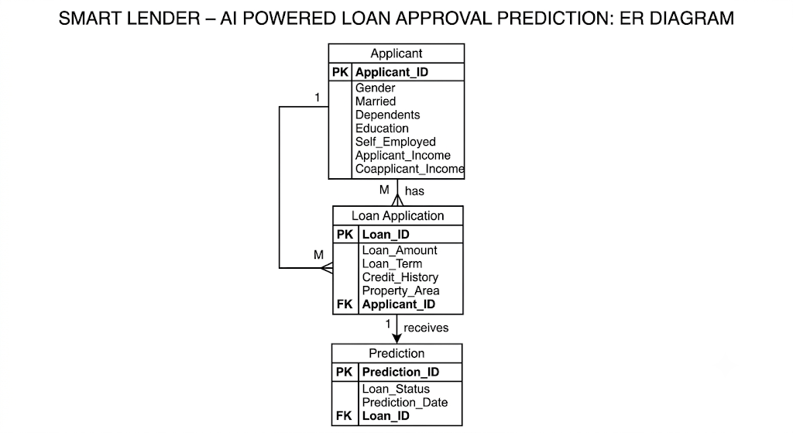

8. PREREQUISITES

Before executing the Smart Lender project, the following software and tools should be installed.

Software

Python 3.x

Flask

Visual Studio Code

Jupyter Notebook

Git

GitHub

Machine Learning Libraries

Pandas

NumPy

Scikit-learn

Matplotlib

Seaborn

Pickle

Web Technologies

HTML5

CSS3

Bootstrap

9. REQUIRED LIBRARIES
Library | Purpose
Pandas | Data preprocessing
NumPy | Numerical computation
Scikit-learn | Random Forest model
Matplotlib | Visualization
Seaborn | Statistical visualization
Pickle | Model serialization
Flask | Backend framework

10. DATASET
The Smart Lender project uses a Loan Prediction Dataset containing historical applicant information and loan approval status.
Input Features
- Gender
- Married
- Dependents
- Education
- Self Employed
- Applicant Income
- Co-applicant Income
- Loan Amount
- Loan Amount Term
- Credit History
- Property Area

Target Variable
- Loan Status
  - Loan Approved
  - Loan Not Approved

The dataset is stored in CSV format and is used for training, testing, and evaluating the Random Forest model.
11. DATA PREPROCESSING
Before training the Machine Learning model, several preprocessing steps were performed to improve data quality and model performance.

Preprocessing Steps
- Reading the dataset
- Handling missing values
- Removing duplicate records
- Encoding categorical variables
- Feature selection
- Splitting features and target variable
- Train-Test Split
- Data validation
These preprocessing techniques ensure that the dataset is clean, consistent, and suitable for training the Random Forest model.

12. EXPLORATORY DATA ANALYSIS (EDA)

Exploratory Data Analysis (EDA) was carried out to understand the characteristics of the loan prediction dataset and identify relationships among applicant attributes.

The following visualization techniques were used:
- Histogram
- Count Plot
- Box Plot
- Correlation Heatmap
- Distribution Plot
- Descriptive Statistics

EDA helped identify feature distributions, detect outliers, and understand how different factors influence loan approval predictions.

13. MODEL BUILDING

13.1 Machine Learning Model Selection
The Smart Lender project uses the Random Forest Classifier, a supervised Machine Learning algorithm for classification. It combines multiple decision trees to improve prediction accuracy and reduce overfitting while handling both categorical and numerical features.
Advantages of Random Forest
- High prediction accuracy.
- Handles missing and categorical data.
- Reduces overfitting.
- Robust against noisy datasets.
- Suitable for real-world classification problems.

13.2 Model Training Process

The model training process consists of the following stages:

Importing the dataset.

Data preprocessing.

Feature encoding.

Splitting the dataset into training and testing sets.

Training the Random Forest model.

Testing the trained model.

Saving the trained model using Pickle.

13.3 Model Parameters

Parameter | Value
Algorithm | Random Forest Classifier
Problem Type | Classification
Target Variable | Loan Status
Training Dataset | Loan Prediction Dataset
Model Output | Loan Approved / Loan Not Approved

14. MODEL EVALUATION
Evaluation metrics include Accuracy, Precision, Recall, F1-Score and Confusion Matrix.
Metric | Description
Accuracy | Correct predictions
Precision | Positive prediction accuracy
Recall | Positive detection rate
F1-Score | Balance of precision and recall
Confusion Matrix | Prediction summary

15. MODEL SAVING

The trained model is saved as model.pkl using Pickle and loaded by Flask for prediction.

Train Model
│
▼
Save Model (model.pkl)
│
▼
Flask Loads Model
│
▼
User Inputs Data
│
▼
Prediction Generated

16. PROJECT STRUCTURE

The Smart Lender project follows a modular folder structure to improve maintainability and readability.

SmartLenderProject/

├── Dataset/

│ └── loan_prediction.csv

│

├── Notebook/

│ └── SmartLender.ipynb

│

├── Flask/

│ ├── app.py

│ ├── model.pkl

│ ├── templates/

│ │ ├── home.html

│ │ └── index.html

│ └── static/

│ └── css/

│ └── style.css

│

├── Screenshots/

│ ├── 01_Home_Page.png

│ ├── 02_Prediction_Form.png

│ ├── 03_Loan_Approved.png

│ └── 04_Loan_Not_Approved.png

│

├── requirements.txt

└── README.md

17. APPLICATION WORKFLOW

The Smart Lender application follows the workflow shown below.

Start
│
▼
Open Smart Lender Web Application
│
▼
Enter Applicant Details
│
▼
Click Predict
│
▼
Flask Receives Input
│
▼
Input Validation
│
▼
Random Forest Prediction
│
▼
Loan Approved / Loan Not Approved
│
▼
Display Prediction
│
▼
End
Workflow Description

- Open the Smart Lender application.
- Enter applicant details.
- Submit the loan prediction request.
- Flask validates the input data.
- The trained Random Forest model processes the information.
- The prediction result is displayed to the user instantly.

18. PROJECT IMPLEMENTATION
The Smart Lender project was successfully implemented using Python, Flask, HTML, CSS, Bootstrap, and the Random Forest Classifier. The application provides a simple web interface that enables users to enter loan applicant information and receive an instant loan approval prediction. The implementation integrates the user interface, backend processing, machine learning model, and prediction output.

18.1 User Interface
The frontend was developed using HTML5, CSS3, and Bootstrap to provide a responsive and interactive interface.

- Responsive homepage
- User-friendly loan application form
- Input validation
- Attractive interface
- Instant prediction display

18.2 Loan Prediction Form
The form collects all required applicant details.

- Gender
- Married
- Dependents
- Education
- Self Employed
- Applicant Income
- Co-applicant Income
- Loan Amount
- Loan Amount Term
- Credit History
- Property Area

After entering all details, the user clicks the Predict Loan Approval button.

18.3 Flask Backend
The backend is implemented using Flask.

- Accept user requests
- Validate input data
- Load trained model
- Perform prediction
- Return prediction result
- Main backend file: app.py

18.4 Machine Learning Integration
The trained Random Forest model is integrated using the Pickle library. The application loads model.pkl during startup and predicts loan approval whenever a user submits the form.
- Model File: model.pkl
- Prediction Output:
Loan Approved / Loan Not Approved

18.5 HTML Templates
- home.html – Home Page
- index.html – Loan Prediction Form

18.6 CSS Styling
Implemented in static/css/style.css
- Responsive layout
- Modern interface
- Button styling
- Form styling
- Result cards

18.7 Project Execution
- Run the application using: python app.py
- Open: http://127.0.0.1:5000
The Smart Lender homepage loads and allows users to perform loan prediction.

18.8 Implementation Screenshots
Home Page
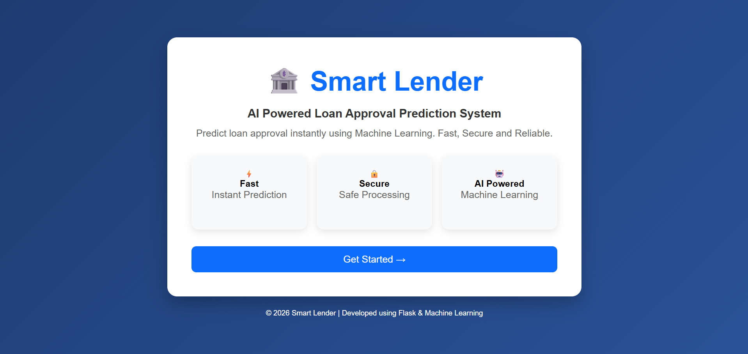

Loan Prediction Form

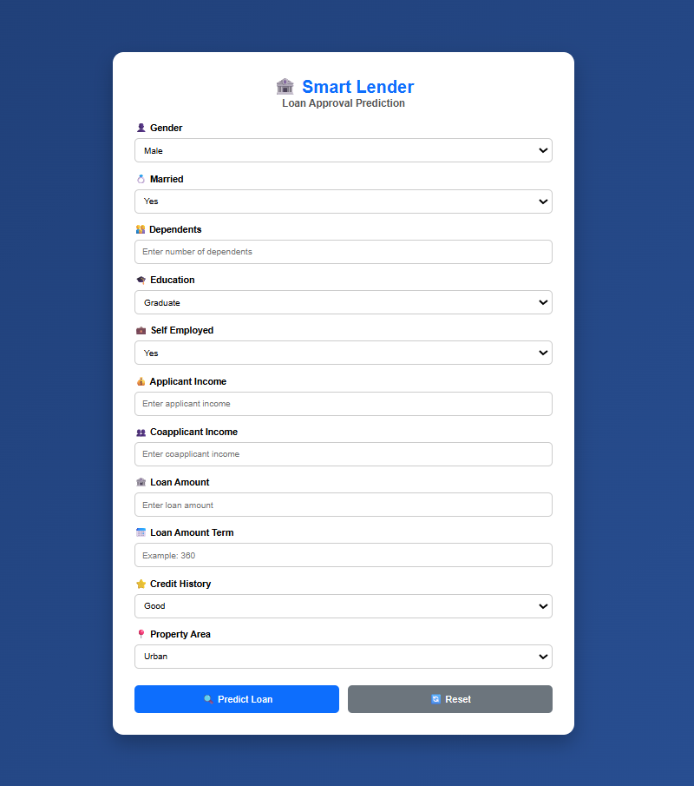
VS Code Project Structure

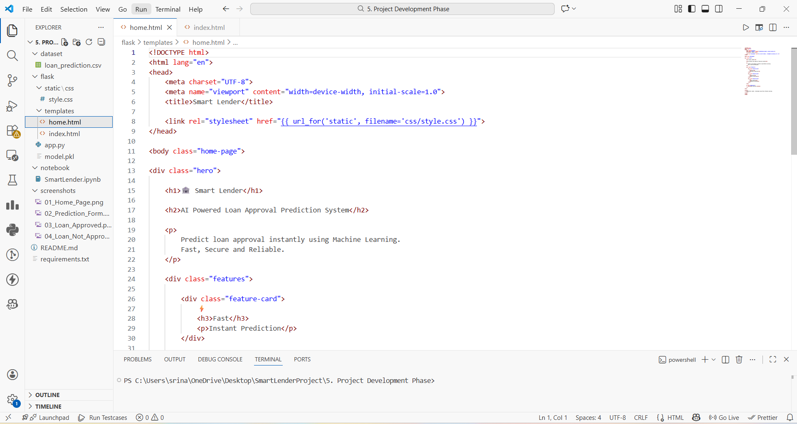

Flask Terminal

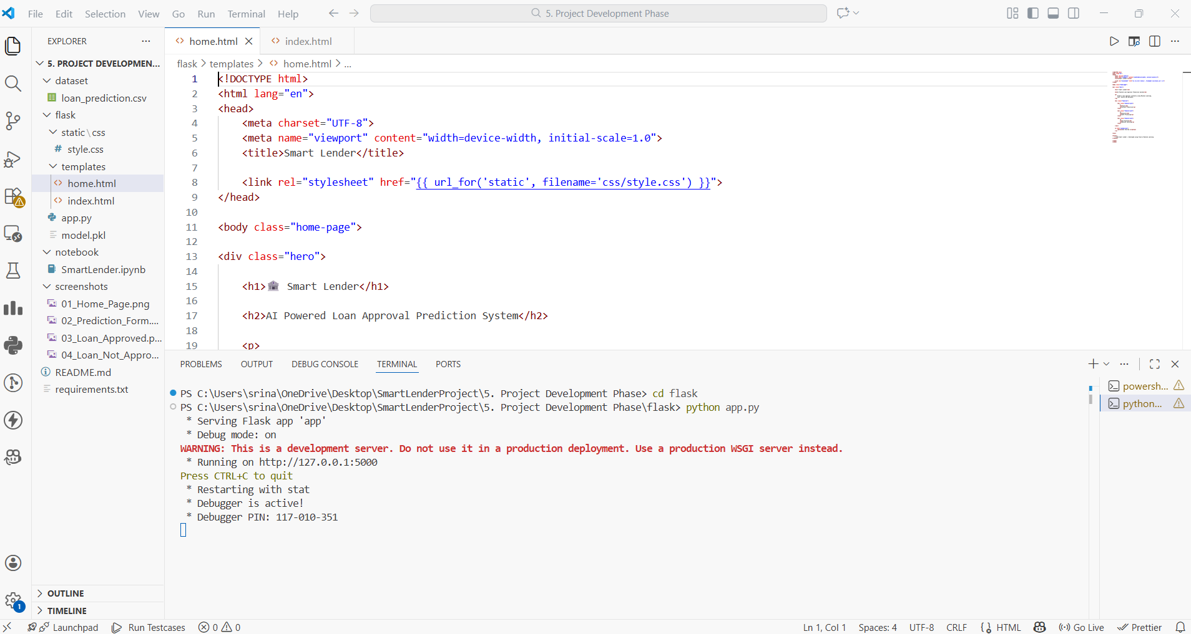

Loan Approved Result

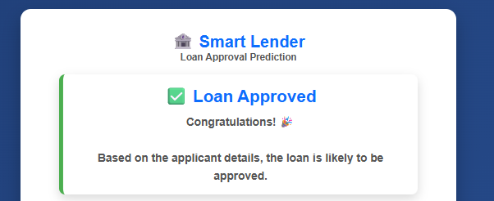

Loan Not Approved Result

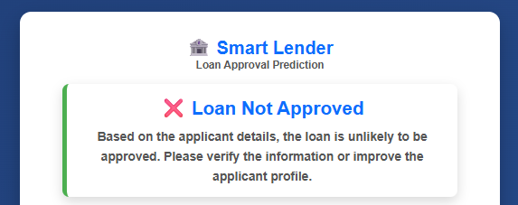

19. RESULTS
The Smart Lender application was successfully developed and tested using historical loan applicant data. The trained Random Forest model accurately predicts whether a loan application is likely to be approved based on applicant information. Integration with the Flask web application enables users to receive instant predictions through an intuitive interface.

Key Results
- Successful implementation of the Random Forest Classifier.
- Accurate prediction of loan approval status.
- Fast prediction response through the Flask application.
- Responsive and user-friendly web interface.
- Effective integration of Machine Learning and web technologies.

19.1 Sample Prediction Results
Applicant Profile | Prediction
Good credit history, stable income | Loan Approved
Poor credit history, insufficient income | Loan Not Approved
Moderate income with positive credit history | Loan Approved
Low income and poor repayment history | Loan Not Approved

20. FUTURE ENHANCEMENTS
The Smart Lender application can be enhanced further by incorporating advanced technologies and additional features.
Proposed Enhancements:

Improve prediction accuracy using advanced ensemble models.

Deploy the application on a cloud platform.

Add user authentication and loan history tracking.

Integrate with banking databases and APIs.

Provide downloadable loan prediction reports.

21. CONCLUSION
The Smart Lender - AI Powered Loan Approval Prediction project successfully demonstrates the practical application of Machine Learning in the banking and financial sector. By utilizing the Random Forest Classifier, the system accurately predicts loan approval status based on applicant information. The Flask-based web application provides an intuitive interface for fast and efficient predictions. The project integrates data preprocessing, Machine Learning, and web development technologies to create a reliable decision-support system that reduces manual effort, improves consistency, and enhances operational efficiency. Future enhancements such as cloud deployment, Explainable AI, and integration with real-time banking systems can further improve scalability and intelligence.

